Task-1: Certain experimental values of x and y are given below:
(0, -1), (2, 5), (5, 12), (7, 20)
If the straight-line Y=a₀+a₁x is fitted to the above data, find the approximate values of a₀ & a₁

Code (Python):
from prettytable import PrettyTable
value_x=[0,2,5,7]
value_y=[-1,5,12,20]
def straight_line():
table=PrettyTable()
table.field_names=["x","y","x*y","x^2"]
m=len(value_x)
x_2=0
sum_x=0
xy=0
sum_y=0
for i in range(m):
x,y=value_x[i],value_y[i]
x_2+=x**2
xy+=x*y
sum_x+=x
sum_y+=y
table.add_row([x,y,x*y,x**2])
table.add_row([f"Σx={sum_x}",
f"Σy={sum_y}",f"Σxy={xy}",
f"Σx^2={x_2}"])
a1=(m*xy-sum_x*sum_y)/(m*x_2-sum_x**2)
a0=(sum_y-sum_x*a1)/m
print(table)
print(f"a0={a0:.5f}\na1={a1:.5f}")

straight_line()

Output:
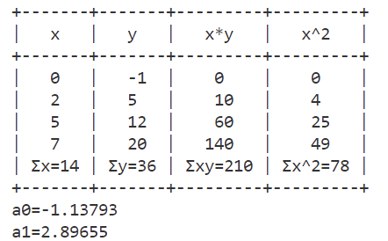
Task-2: Fit a polynomial of the second degree to the data points (x, y) given by
(0, 1), (1, 6) and (2, 17)

Code (Python):
import numpy as np
from prettytable import PrettyTable
value_x=[0,1,2]
value_y=[1,6,17]
def parabolic():
table=PrettyTable()
table.field_names=["x","y","x^2","x^3","x^4","x*y","x^2*y"]
m=len(value_x)
x_2=0
x_3=0
x_4=0
x2y=0
sum_x=0
xy=0
sum_y=0
for i in range(m):
x,y=value_x[i],value_y[i]
x_2+=x**2
xy+=x*y
sum_x+=x
sum_y+=y
x_3+=x**3
x_4+=x**4
x2y+=(x**2)*y
table.add_row([x,y,x**2,x**3,x**4,x*y,(x**2)*y])
table.add_row([f"Σx={sum_x}",f"Σy={sum_y}",
f"Σx^2={x_2}",f"Σx^3={x_3}",
f"Σx^4={x_4}",f"Σxy={xy}",
f"Σx^2*y={x2y}"])
A=np.array([[m,sum_x,x_2],
[sum_x,x_2,x_3],
[x_2,x_3,x_4]])
B=np.array([sum_y,xy,x2y])
X=np.linalg.solve(A,B)
print(table)
print(f"a0={X[0]:.2f}\na1={X[1]:.2f}\na2={X[2]:.2f}")

parabolic()

Output:
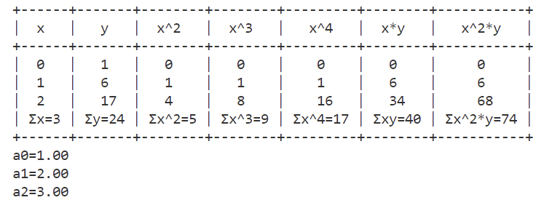

Discussion:
Here I have discussed the Least Square Curve Fitting Problem where I have mentioned Linear Curve like Straight-line(2D) and Non-linear curve like polynomial where the equation is a parabolic function (The highest power of x is 2).

